Example MLR Influence Diagnosticcs
Singh

Example bodyfat data
library(readxl)
bodyfatdat <- read_excel("C:/Users/Pradeep Singh/Documents/Professional/CSDA5110/Fall_2024/Week6/bodyfat_data.xlsx")
View(bodyfatdat)
head(bodyfatdat)
## # A tibble: 6 × 4
## triceps thigh midarm bodyfat
## <dbl> <dbl> <dbl> <dbl>
## 1 19.5 43.1 29.1 11.9
## 2 24.7 49.8 28.2 22.8
## 3 30.7 51.9 37 18.7
## 4 29.8 54.3 31.1 20.1
## 5 19.1 42.2 30.9 12.9
## 6 25.6 53.9 23.7 21.7

Regression Coefficients
library(api2lm)
output_1 <- lm(bodyfat~triceps+thigh + midarm, bodyfatdat)
summary(output_1)
##
## Call:
## lm(formula = bodyfat ~ triceps + thigh + midarm, data = bodyfatdat)
##
## Residuals:
## Min 1Q Median 3Q Max
## -3.7263 -1.6111 0.3923 1.4656 4.1277
##
## Coefficients:
## Estimate Std. Error t value Pr(>|t|)
## (Intercept) 117.085 99.782 1.173 0.258
## triceps 4.334 3.016 1.437 0.170
## thigh -2.857 2.582 -1.106 0.285
## midarm -2.186 1.595 -1.370 0.190
##
## Residual standard error: 2.48 on 16 degrees of freedom
## Multiple R-squared: 0.8014, Adjusted R-squared: 0.7641
## F-statistic: 21.52 on 3 and 16 DF, p-value: 7.343e-06
anova(output_1)
## Analysis of Variance Table
##
## Response: bodyfat
## Df Sum Sq Mean Sq F value Pr(>F)
## triceps 1 352.27 352.27 57.2768 1.131e-06 ***
## thigh 1 33.17 33.17 5.3931 0.03373 *
## midarm 1 11.55 11.55 1.8773 0.18956
## Residuals 16 98.40 6.15
## ---
## Signif. codes: 0 '***' 0.001 '**' 0.01 '*' 0.05 '.' 0.1 ' ' 1

Leverage
library(api2lm)
library(stats)
output_1 <- lm(bodyfat~triceps+thigh + midarm, bodyfatdat)
influence.measures(output_1)
## Influence measures of
## lm(formula = bodyfat ~ triceps + thigh + midarm, data = bodyfatdat) :
##
## dfb.1_ dfb.trcp dfb.thgh dfb.mdrm dffit cov.r cook.d hat inf
## 1 -0.76003 -0.73124 0.75945 0.70490 -1.0997 1.102 0.279049 0.341
## 2 0.39910 0.39630 -0.39928 -0.38929 0.4929 1.098 0.059588 0.157
## 3 0.38184 0.34357 -0.34199 -0.43892 -1.1130 1.552 0.298963 0.440
## 4 0.04597 0.02572 -0.03277 -0.05433 -0.4720 0.936 0.053166 0.112
## 5 -0.21136 -0.22166 0.20918 0.23724 0.4239 1.863 0.046928 0.361 *
## 6 -0.00811 -0.00702 0.00556 0.01318 -0.0888 1.470 0.002095 0.132
## 7 -0.14676 -0.13650 0.14564 0.13394 0.2997 1.457 0.023368 0.194
## 8 0.42242 0.43613 -0.43410 -0.40581 0.6311 0.933 0.093552 0.164
## 9 0.22537 0.21332 -0.21427 -0.23491 0.3689 1.381 0.034970 0.193
## 10 0.24480 0.24716 -0.25016 -0.23408 -0.3181 1.567 0.026415 0.241
## 11 -0.05221 -0.04607 0.04953 0.05052 0.1368 1.459 0.004949 0.139
## 12 -0.00565 0.00744 0.00265 -0.00522 0.3292 1.156 0.027293 0.109
## 13 0.34014 0.38223 -0.36835 -0.33266 -0.8195 0.894 0.153739 0.214
## 14 -0.39648 -0.43078 0.40092 0.44798 0.9705 0.611 0.197600 0.188
## 15 -0.07349 -0.09525 0.08663 0.07328 0.3520 1.868 0.032544 0.348 *
## 16 0.01070 0.01165 -0.01123 -0.01052 0.0257 1.460 0.000176 0.114
## 17 0.02634 0.02581 -0.02714 -0.02345 -0.0591 1.470 0.000929 0.125
## 18 -0.10507 -0.11135 0.10096 0.12603 -0.3393 1.514 0.029927 0.228
## 19 -0.48298 -0.46695 0.47643 0.46861 -0.6666 0.734 0.099235 0.132
## 20 0.03272 0.03230 -0.03235 -0.03232 0.0659 1.364 0.001152 0.066
influence_plot(output_1)
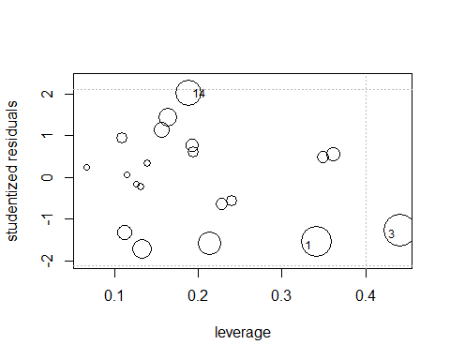
plot(output_1, which = 4)
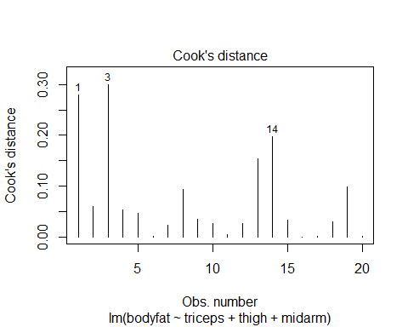
plot(output_1, which = 5)
